SDDL – RESULTS SHEET

Division: _______________________ Date: ____ /____ /____

Home: ________________________ Away:__________________________

Four-a-side Signature Four-a-side Signature
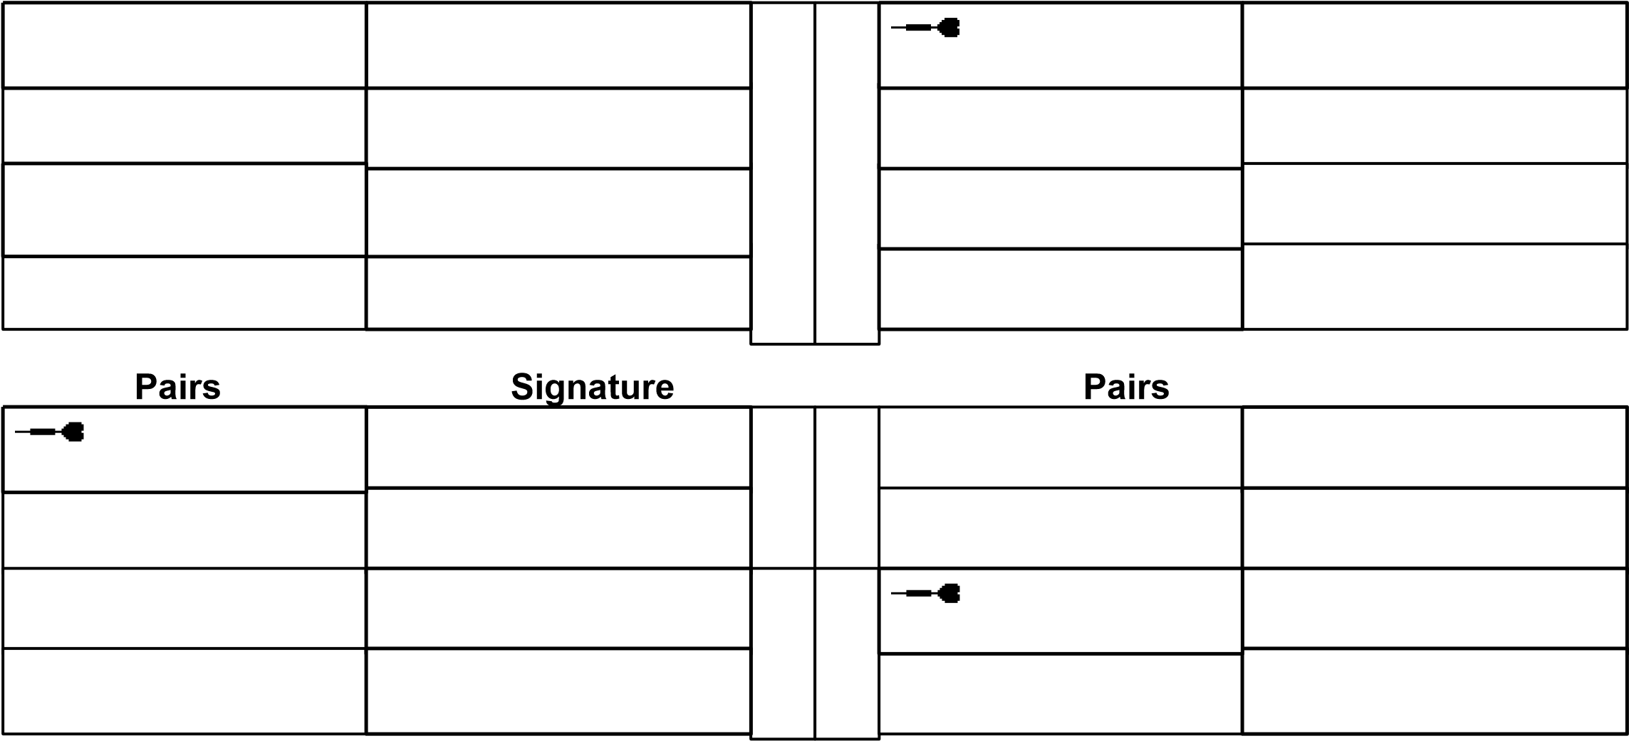

Singles Signature Singles Signature

Away Captain Signatu

Home Captain Signature
re

Player to throw first in 1st and 3rd legs

Special Comments: (Trophies for highest out and most 180’s) All Results to: Andy Tranter
10 Charlbury Road,
Shrivenham, Swindon
Wilts, SN6 8EQ
You can email results to Andy Tranter: f111@btinternet.com or Text to 07789108431
Please include match result and any 180's or check outs. Please keep result sheet in case of any queries.
www.swindonddl.co.uk

